Dear __________________________________
Mrs. Riya & Mr. Rupesh Ghorpade
and Mrs. Radhika & Mr. Gurunath Subhedar
Cordially invite you to grace this
auspicious occasion of their Childrens
Swaraj with Swara
On Saturday, 3rd March 2018
Jaan Arrival : 11.15 am
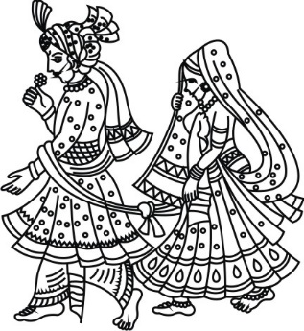
followed by the Wedding Ceremony & Lunch
Morjaria Residence
5 Mansion House Drive, Stanmore
Middlesex, HA7 3GA
Dress Code : Indian Traditional
LOGOS/SYMBOLS IN THE DOCUMENT CAN BE CHANGED (IF REQUIRED) TO THE LOGOS/SYMBOLS CHOSEN FROM OUR LIBRARY.
CLICK HERE TO BROWSE OUR LIBRARY OF LOGOS/SYMBOLS.

Dear __________________________________
Swaraj & Swara
Would be delighted to host you
for a special evening
On Sunday, 4th March 2018
Cocktails : 7.00 pm
Reception : 8.00 pm
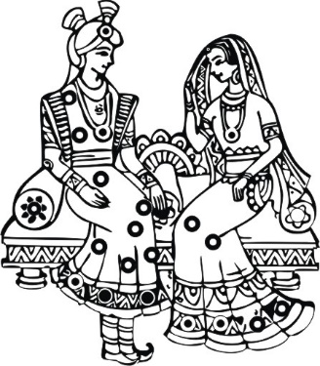
followed by Dinner & Dance
Grand Ballroom
Hilton Park Lane, 22 Park Lane,
London W1K 1BE
LOGOS/SYMBOLS IN THE DOCUMENT CAN BE CHANGED (IF REQUIRED) TO THE LOGOS/SYMBOLS CHOSEN FROM OUR LIBRARY.
CLICK HERE TO BROWSE OUR LIBRARY OF LOGOS/SYMBOLS.

Dress Code : Black Tie / Indian Formal

